MySQL Assignment 1:

DDL Commands

* Create a database named School and perform all the DDL commands(CREATE, ALTER, DROP, RENAME, TRUNCATE) for the table named STUDENT with fields: Roll_No Name Marks Grade
* Create data on your own based on the given columns

(1) Use the select command to display the table.

(2) Add a column named Contact to the STUDENT table.

(3) Remove the Grade column from the Student table.

(4) Rename the table to CLASSTEN.

(5) Delete all rows from the table. (6) Remove the table from the database.

Ans:

-- create database

create database School;

-- select database

use School;

-- create fields

create table Student(

Roll_No INT PRIMARY KEY,

Name varchar(30),

Marks INT,

Grade varchar(3)

);

-- show table

desc Student;

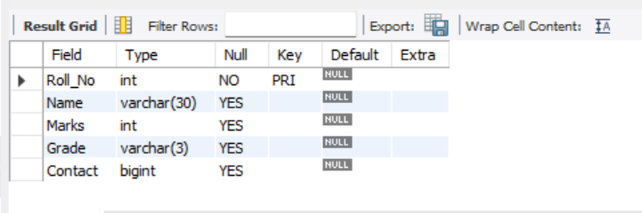

-- insert values

insert into Student values(1, 'Amal Baby', 87, 'A');

insert into Student values(2,'Anandu O A',89,'A');

insert into Student values(3,'Anjaly',93,'A+');

insert into Student values(4,'Anaswa',97,'A+');

insert into Student values(5,'Aswathy',90,'A+');

insert into Student values(6,'Akhil',99,'A+');

insert into Student values(7,'Abhirami',86,'A+');

insert into Student values(8,'Vishnu',75,'B+');

insert into Student values(9,'Aby',68,'C');

insert into Student values(10,'Basil',69,'C');

insert into Student values(11,'Ansal',78,'B+');

insert into Student values(12,'Adith',84,'A');

insert into Student values(13,'Amaljith',63,'B');

insert into Student values(14,'Athira',88,'A');

-- show table

select * from Student;

-- add new column

alter table student add Contact bigint;

update student set Contact = 8281365067 where roll_no = 2;

-- remove column grade

alter table student01 drop grade;

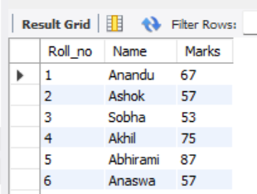

-- rename table name

rename table student01 to ClassTen;

desc classten;

select * from classten;

-- delete all rows from table

truncate classten;

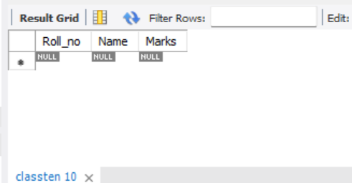

-- remove table from database

drop table classten;

